AWS Lambda Service

Objectives of AWS Lambda
AWS Lambda is Amazon's serverless compute service. By the end of this guide, you will understand and be able to achieve the following objectives:

1. Run Code Without Managing Servers
Lambda automatically provisions, scales, and manages the infrastructure required to run your code. You focus purely on writing business logic.
2. Automatic Scaling
Lambda scales automatically from a few requests per day to thousands per second. Each invocation runs in its own isolated environment, ensuring consistent performance.
3. Pay Only for What You Use
You are charged only for the compute time your code consumes (measured in milliseconds) and the number of requests. There is no charge when your code is not running.
4. Support Multiple Runtimes
Lambda supports multiple programming languages including Python, Node.js, Java, Ruby, .NET, and custom runtimes — giving teams flexibility to use their preferred language.
5. Create and Deploy Functions Quickly
Using the AWS Console, you can author, test, and deploy a Lambda function in minutes without any complex setup or server configuration.

Step-by-Step:Creating Your First Lambda Function

Step 1: Open AWS Lambda Console
Log in to your AWS Management Console
In the search bar at the top, type Lambda and select it from the results.
You will land on the AWS Lambda home page which shows the tagline: 'Run code without managing servers.'
Click the orange Create a function button on the right-hand side to get started.
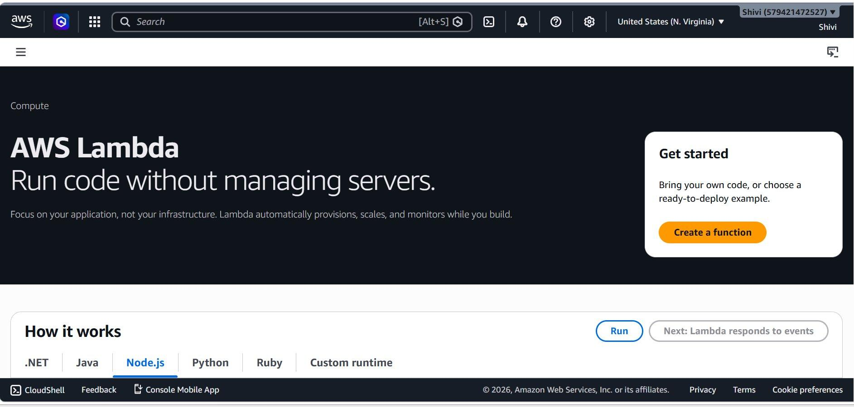

Step 2: Configure Your Function
On the Create function page, select Author from scratch
Under Basic information, enter a Function name. In this example: myfunctionShivi.
For Runtime, select your preferred language. Here Python 3.14 is selected.
Leave all other settings at their defaults for now.
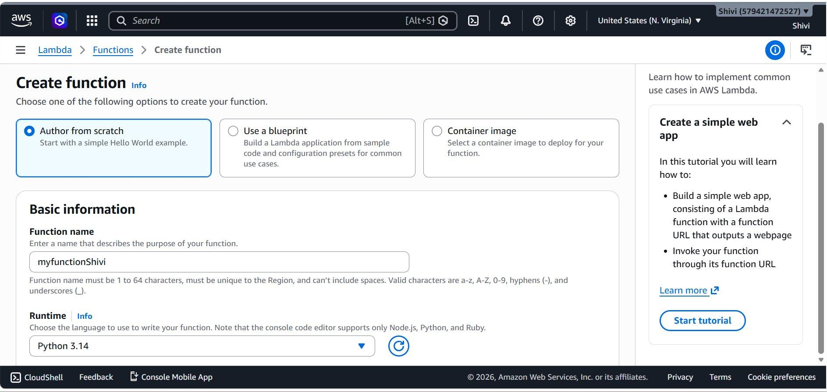

Step 3: Review Custom Settings
Leave the Custom settings and other optional configurations as their default values.
Once all details are verified, select the Create function option to complete the setup of the AWS Lambda function.
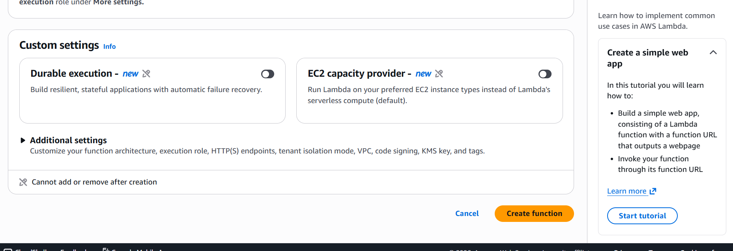

Step 4: Function Created Successfully
After creation, a 'Getting started' modal appears
Click Dismiss to close the modal and proceed to the function editor.
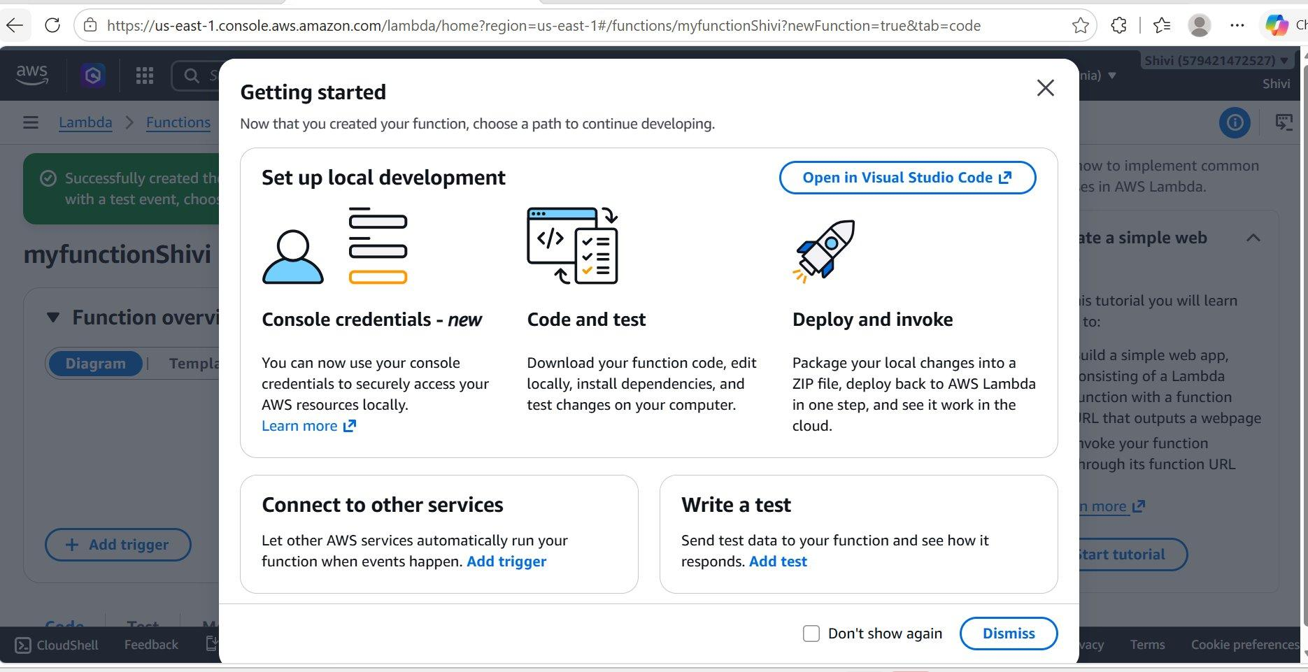

Step 5: View the Code Source Editor
After dismissing the modal, you will see the Code source section.
A green success banner confirms: 'Successfully created the function myfunctionShivi.'
The inline editor shows the default lambda_function.py with a Hello World handler:
import json
def lambda_handler(event, context):
return { 'statusCode': 200, 'body': json.dumps('Hello from Lambda!') }
You can edit this code directly or click Open in Visual Studio Code for local development.
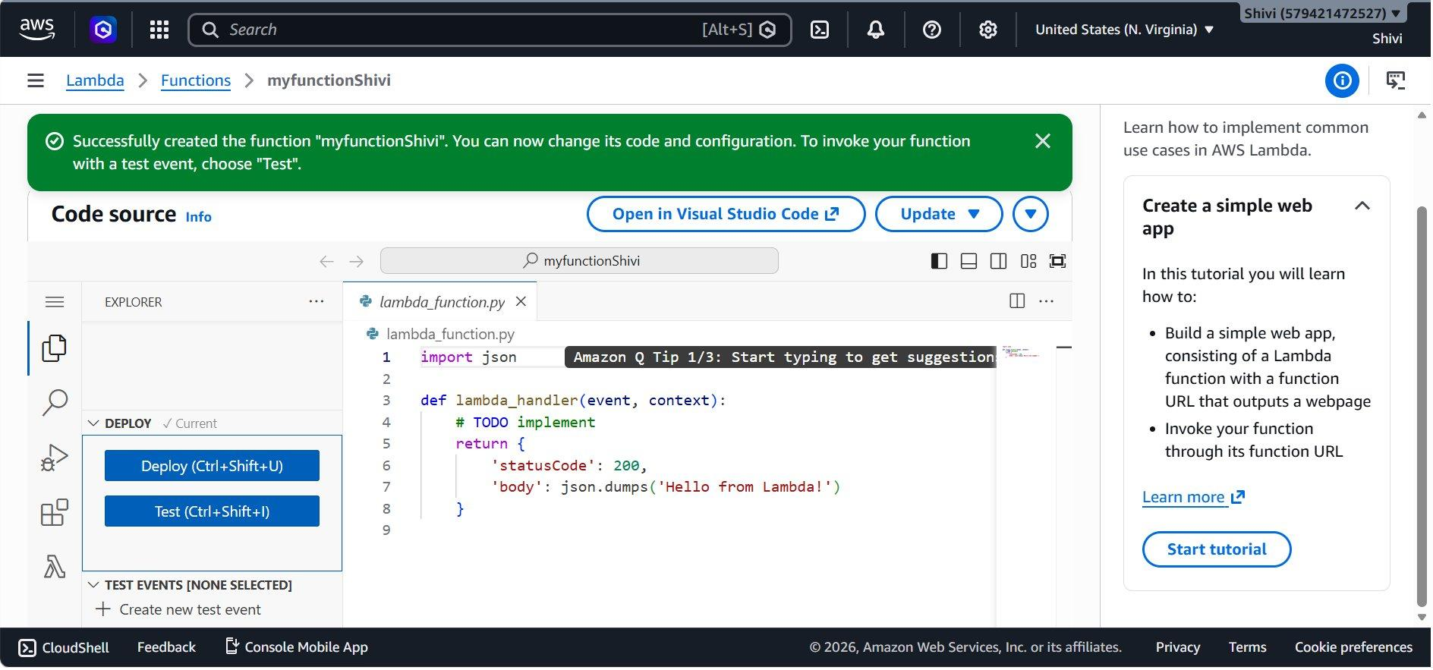

Step 6: Create a New Test Event
In the left sidebar under TEST EVENTS, click + Create new test event.
A panel titled 'Create new test event' opens on the right.
Enter an Event Name (max 25 characters). Here: mytemplate.
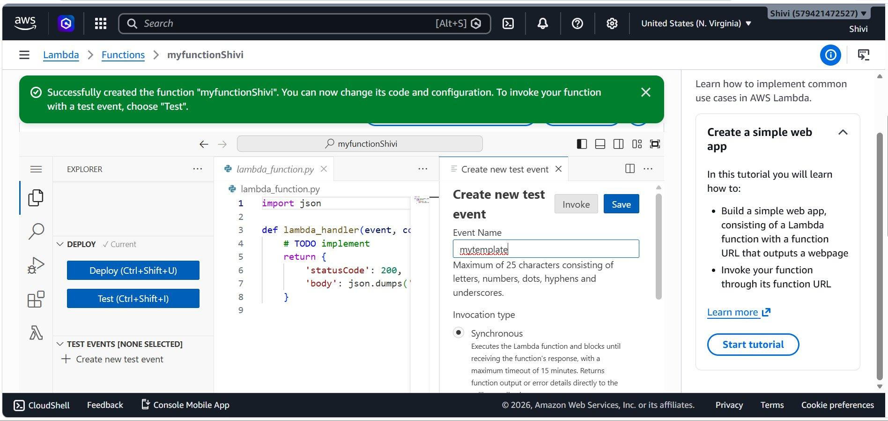

Step 7: Configuration Type
Under Event sharing settings, choose:
Private
Shareable
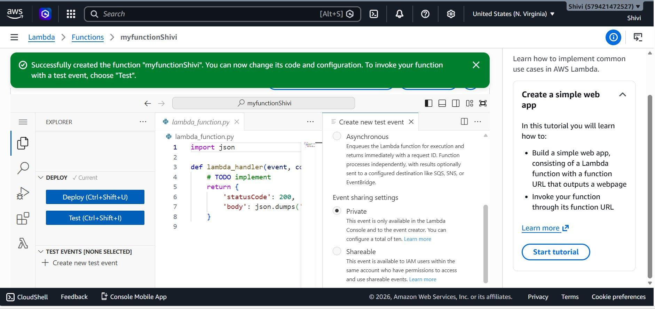

Step 8: Set the Event Template and JSON
Under Template, select Hello World from the dropdown.
The Event JSON section auto-populates with sample key-value pairs:
{ "key1": "value1", "key2": "value2", "key3": "value3" }
You can modify this JSON to match your function's expected input format.
Click Save to store the test event, or click Invoke to save and run immediately.
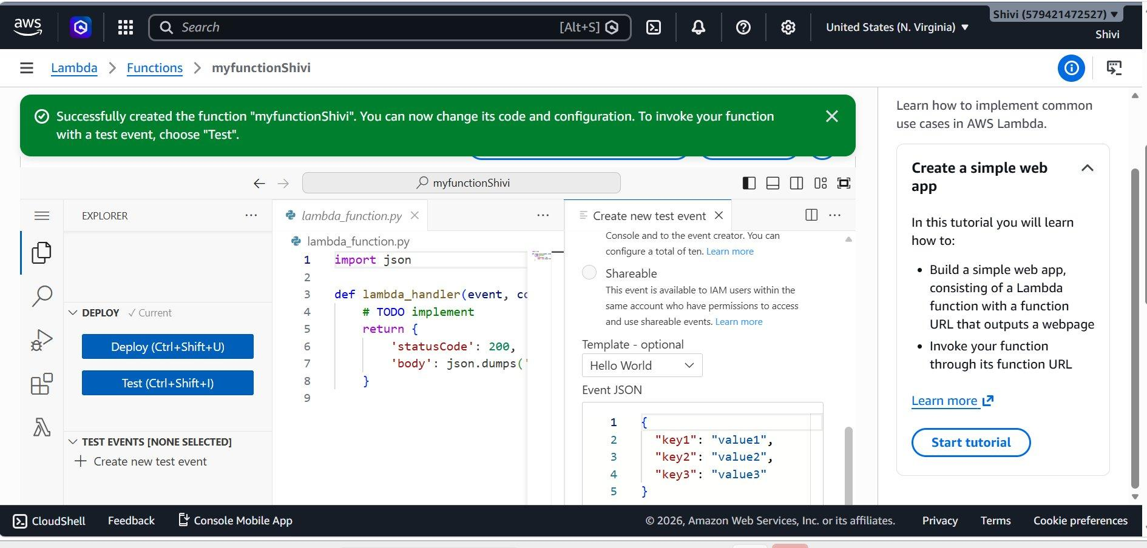

Step 9: Test Event Saved Successfully
A green banner confirms: 'The test event mytemplate was successfully saved.'
The left sidebar now shows TEST EVENTS [SELECTED: MYTEMPLATE]
You are now ready to invoke the function using this test event.
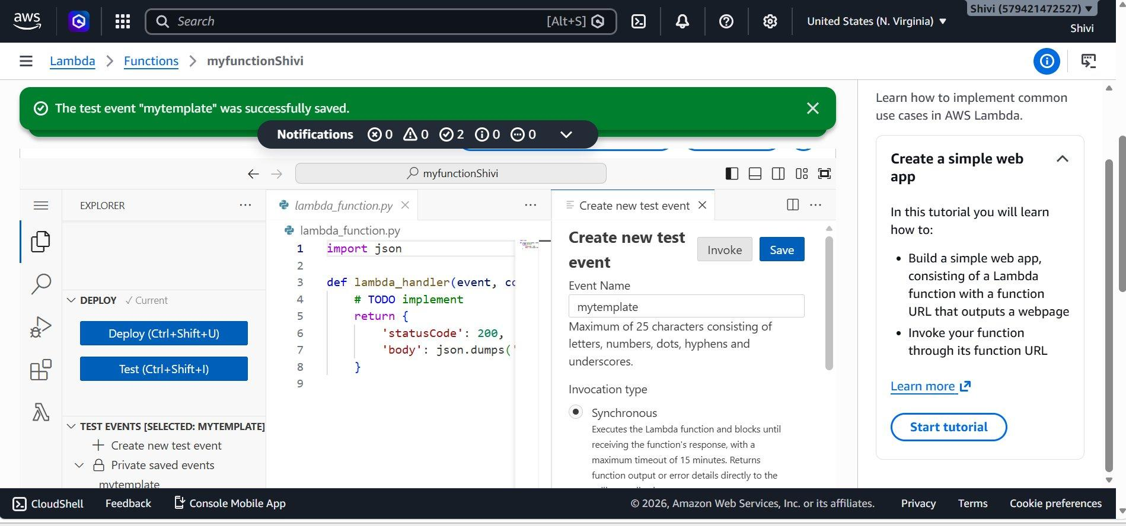

Step 10: View Execution Results
After invoking the function, the OUTPUT panel at the bottom shows the Execution Results.
Status: Succeeded confirms the function ran without errors.
Test Event Name: mytemplate shows which event was used.
The Response section displays the function output:
{ "statusCode": 200, "body": "\"Hello from Lambda!\"" }
The status bar at the bottom shows Lambda Deployed, confirming the function is live.
